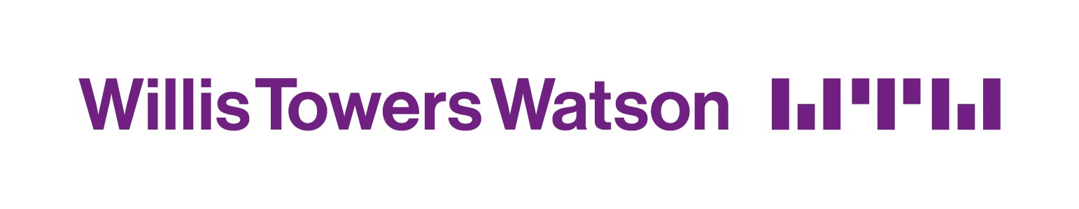

**SDET Scripting Test**

**Purpose**

As it is difficult to fully assess somebody’s abilities at an interview, particularly their scripting skills and reporting skills. We give the following task to all the potential recruits. The problems should be completed in the applicant’s own time.

Q1. Write a parameterized PowerShell script to install and uninstall this test software ([https://notepad-plus-plus.org](https://notepad-plus-plus.org/download/v5.9.8.html)) from a *given network location*. Install only if a newer version is available.

<https://github.com/shksumit/WTW-Technical-Test/blob/main/Ps1%20-%20Check%20current%20version.ps1>

Q2. Write 5 most important test cases for the following sample login screen:

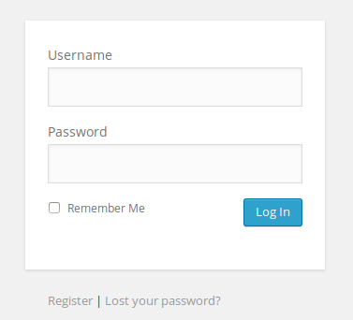

* Verify providing access to only valid username and password combination
* Verify incorrect username and password combination are not allowed access
* Verify Remember Me function for re-login process
* Verify new user registration process access from **‘Register’** button and new user Login process
* Verify ‘**Lost your password’** button and email to recover password

Q3. Please outline your automated test framework design ideas for the following sample Rest API method:

**Tools**

Programming Language – JavaScript

IDE –Microsoft Code

Automation tool – Postman

CI and Build tool – Jenkins

Read Excel – Apache POI Libraries

Repository - Github

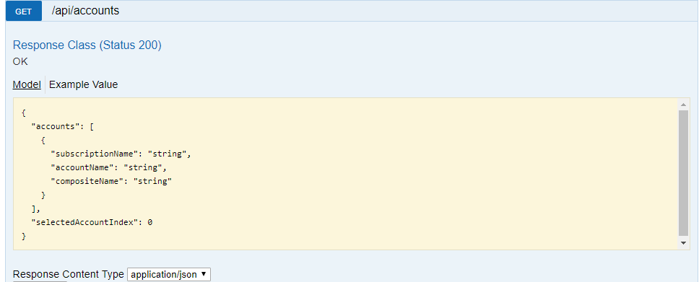

Q4. Write a C# console application that will compare two large csv files (30+ MB each) and output the differences. Please add some unit tests as well to validate the implementation.

<https://github.com/shksumit/WTW-Technical-Test/tree/main/FileReadWrite>